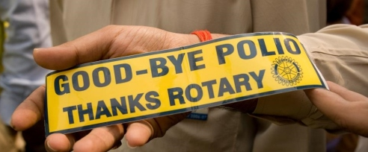
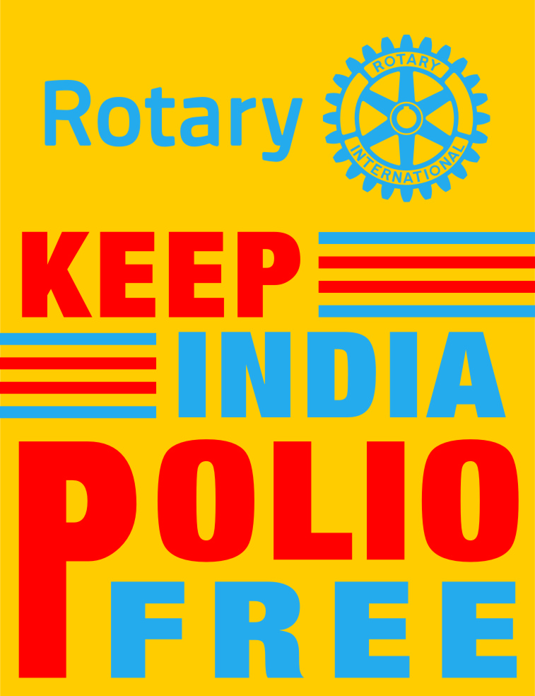

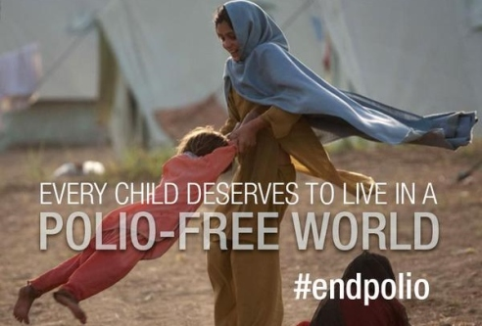

POLIO UPDATE BACK AGAIN TO MEET POPULAR DEMAND

6TH JANUARY 2016.
Dear All,
CONGRATULATIONS! Rotary Year 2015-16continues with a clean slate on Polio in India.
New polio cases due to wild polio virus reported this week – 0

Total polio cases due to wild polio virus in 2015/2016 – 0

NIDS FOR PULSE POLIO:
JANUARY 17 &
FEBRUARY 21.2016

Wednesday, December 16, 2015

Another year, another step closer to a polio-free world

Progress in 2015 has laid the groundwork for a final push towards a polio-free world.
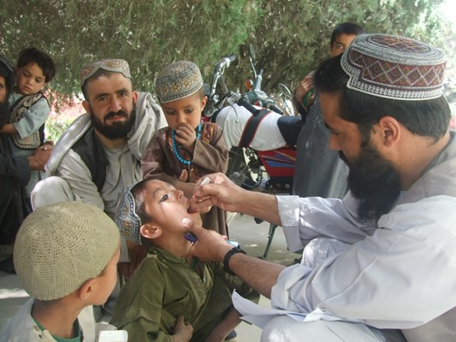
A child is vaccinated with oral poliovirus vaccine during a National Immunization Day in Afghanistan.
WHO/Afghanistan
When we look back on 2015, it may well be seen as the year the tide irreversibly turned on polio. Wild poliovirus is more geographically constrained than it has been at any point in recorded history. As of 10 December 2015, 66 wild poliovirus cases have been reported from the only two remaining polio endemic countries, Pakistan and Afghanistan, compared to the 324 cases found in nine countries during the same period in 2014.
From Nigeria being removed from the list of polio endemic countries to the declaration of wild poliovirus type 2 (WPV2) eradication to the closure of several outbreaks, progress against polio has accelerated in its remaining strongholds. We are rapidly closing in on the finishing line.
While we saw important steps forward this year, we also faced challenges which we must address in 2016 to achieve a polio-free world.
Nigeria polio-free
In 2015, the three remaining polio endemic countries were reduced to two.
After many years of determination and hard-work, Nigeria reached one year without polio on 24 July, and was removed from the endemic country list in September. With large populations in remote, hard-to-reach areas, as well as regional insecurity, success in Nigeria was thanks to renewed political commitment and attention to detail at every level of the programme. August 11 marked one year without any wild poliovirus across the entire African continent. The hard work must continue if Africa is to be declared polio-free; in Nigeria and other at risk countries in Africa, the focus must shift from stopping transmission to building resilience. Three years with no case of wild polio are needed for the WHO Africa Region to be declared polio-free.
Progress in Afghanistan and Pakistan
Cases in Afghanistan remained low in 2015, with a total of 16 cases compared to 21 by this time in 2014. While in 2014 most cases in Afghanistan came from cross border transmission from Pakistan, this year saw endemic cases in areas of the south and east. Security threats continued to pose a threat to reaching children with vaccines in some areas of the country; but healthcare workers and volunteers continued to work tirelessly to protect children everywhere, as can be seen in this photo story.
Vast improvements have been seen in Pakistan, with more than 80% fewer cases in the country than in 2014. In part, this is thanks to the establishment of the Emergency Operations Centre (EOC), which serves as a platform for increased government ownership of the polio programme. The EOC has played an important role in the implementation of new strategies such as health camps, which have reached almost 350,000 people in high-risk areas, with additional health services alongside polio vaccines this year. Encouragingly, the number of inaccessible children has declined to just 35,000 in comparison to 300,000 in 2014. While this gives much cause for optimism, environmental surveillance shows widespread transmission continues in several provinces. Pakistan must leverage the low-season to the best of its ability if we are to be successful in eliminating transmission in 2016.
Political commitment
In May, the sixty-eighth World Health Assembly adopted a landmark resolution to finish polio once and for all. This puts into place all the necessary building blocks to complete the polio endgame and urges all member states to fully implement and finance it.
Securing a polio-free world
The switch
To make the world polio-free, we must stop all kinds of poliovirus. While wild poliovirus cases are at an all-time low, circulating vaccine-derived polioviruses (cVDPVs) are taking on an increasing significance in the eradication endgame. In 2015, more countries were affected by cVDPVs than by WPVs, giving them a greater precedence and illustrating how important the trivalent to bivalent OPV switch will be in 2016.
In 2015, WPV2 was declared eradicated with no case since 1999 in northern India.
This was one of the factors that enabled the Strategic Advisory Group of Experts on immunization (SAGE) to give the go-ahead for the globally synchronised trivalent to bivalent oral polio vaccine (OPV) switch in April 2016. This will play an important role in preventing the emergence of cVDPVs.
This year saw six countries affected by cVDPV outbreaks: Guinea, Lao People’s Democratic Republic, Madagascar, Myanmar, Nigeria and Ukraine. This is far less than in 2015, but the fact that any cases continue to be found underlines the fact that children are still under-immunized.
Ahead of the switch, all we are focused on fully stopping residual cVDPV2 transmission everywhere. By the close of 2015, 83% of the global birth cohort will be receiving a routine dose of the inactivated polio vaccine, which will boost immunity against all polioviruses and provide a base-layer of protection against type 2. This includes all of the highest risk countries that have reported cVDPV2 transmission since 2000 or that are endemic for wild polio.

The polio legacy

Countries and partners have also continued to ensure that the polio infrastructure continues to pay dividends for other health programmes once polio has been eradicated. In the last 26 years, the GPEI has mobilized and trained millions of health workers and volunteers, accessed households untouched by other health initiatives and established a global surveillance and response capacity which has huge potential to contribute to future health objectives. Countries with a strong polio eradication presence have begun to plan for the transition of the polio infrastructure to other programmes; but at the same time, the polio infrastructure is already strengthening routine immunization, reaching remote children with other health services and was also integral in fighting Ebola in western Africa.
Looking ahead
As we enter the home stretch, it is more important than ever that we maintain the momentum that has brought us this far. In order to fully eradicate poliovirus, and remove the burden of polio from all future generations, high coverage of immunization is essential. Surveillance must be improved yet further to ensure polio is rooted out from all existing reservoirs. Funding must continue until every last case is found.
2015 has been a great year in the fight against polio. With continued drive and commitment we can make 2016 even better.
- See more at: http://www.polioeradication.org/mediaroom/newsstories/Another-year--another-step-closer-to-a-polio-free-world/tabid/526/news/1329/Default.aspx#sthash.CiYzZtDL.dpuf

‘Rotary International helped to reduce polio cases in 2014’ - RI President K R Ravindran
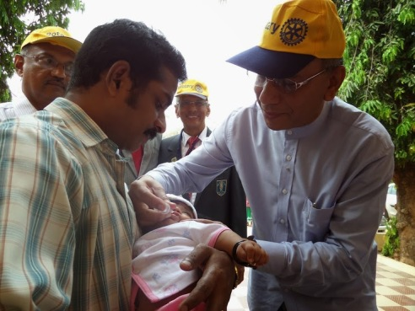In a world where various pressing humanitarian challenges continue to prevail, Rotary International—one of the world's largest humanitarian service organizations—by way of one of its major corporate projects, has already managed to make a remarkable difference in the lives of the global community stricken by polio, said K R Ravindran, president of Rotary International. He was in Goa recently to recognize the work of the Rotary Club of Goa and Rotary international district 3170.
The goal was achieved thanks to a contribution of resources worth $11 billion, he added.
With noteworthy organizations such as UNICEF, CDC, WHO and the Bill and Melinda Gates foundation also working in collaboration with governments to vaccinate 2.5 billion children across 122 countries, polio is now on the brink of eradication. "Less than 370 polio cases were confirmed worldwide in 2014, which is a reduction of more than 99.9 % since the 1980's, a period during which the world saw 1,000 cases per day," Ravindran told TOI.
So far, only two countries — Afghanistan and Pakistan— haven't been able to contain transmission of the wild polio virus on account of geographical isolation, poor public infrastructure and armed conflicts.
Another commendable project supported by Rotary International is the 'WASH in Schools' programme— a permanent project focussing on water, sanitation and hygiene in schools - that has facilitated the construction of 40,000 toilet blocks in 4,000 schools across India and the supply of clean drinking water, in an attempt to not only educate children about sanitation, but to also prevent the spread of diseases contracted through water.
"The 'WASH in schools' programme has been implemented in a few Goan schools, for now. Some government-aided primary schools in Old Goa and Our Lady of Merces School in Merces are among those who have benefited from this initiative," said chairman of the Indian Red Cross, Gaurish Dhond.
- Reprinted from Times of India
- Mithali Rathod in The Times of India, Goa. Jan 5

Polio Eradication: Is 2016 The Year? - National Geographic
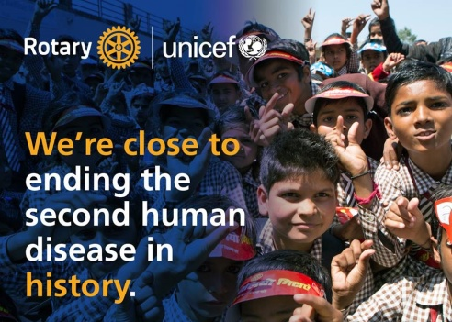
As Yogi Berra (or Niels Bohr or Samuel Goldwyn) is supposed to have said, it’s difficult to make predictions, especially about the future. It’s especially dangerous to try to predict the behavior of infectious diseases, when small unpredictabilities in climate or trade or the behavior of governments can bring a problem that we thought was handled roaring back to life.
But as 2016 opens, it is fair to say that the disease public health experts are pinning their hopes on, the one that might truly be handled this year, is polio. There were fewer cases last year than ever in history: 70 wild-type cases, and 26 cases caused by mutation in the weakened virus that makes up one of the vaccines, compared to 341 wild-type infections and 51 vaccine-derived ones the year before. Moreover, those wild natural infections were in just two countries, Afghanistan and Pakistan, and the vaccine-derived cases were in five. The noose is tightening.
The most that health authorities can hope for this year is to end transmission of polio. The ultimate goal is eradication, which has happened only twice—for one human disease, smallpox, and one animal one, rinderpest. To declare a disease eradicated requires that the entire world go three years without a case being recorded. If there are no polio cases in 2016, eradication might be achieved by the end of 2018.
Which would make for nice round numbers, because the polio eradication campaign began in 1988. It is safe to say that no one expected it would take anywhere near this long; the smallpox eradication campaign, which inspired the polio effort, reached its goal in 15 years.
Smallpox was declared eradicated in 1980, so long ago that most people have no knowledge of how devastating a disease it was, or even what a case of the disease looked like. (There are survivors left, but they are aging; the last person infected in the wild, Ali Maow Maalin of Somalia, died in 2013.) In the same way, we’ve forgotten how difficult it is to conduct an eradication campaign. Smallpox was the first campaign that succeeded, but it was the fifth one that global authorities attempted. In its success, it demonstrated what any future campaign would need: not just a vaccine that civilians could administer, but an easy-to-access lab network, granular surveillance, political support, huge numbers of volunteers, and lots and lots of money.......
Read Maryn McKenna's Blog in National Geographic

US Government Approves $228 Million in Funds for Polio Eradication
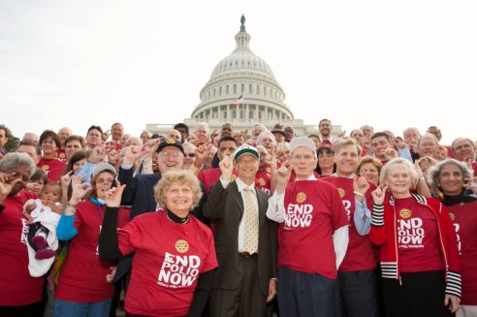The US Congress has approved a total of $228 million for the 2016 federal budget to support global polio eradication efforts in continuation of the country’s longstanding leadership in the fight to end polio. The funding represents a $10 million increase over the level of funding provided in fiscal year 2015.
The financial support will aid the continued polio eradication activities of the Centers for Disease Control and Prevention and the U.S. Agency for International Development, which are working in polio endemic and at-risk countries to eliminate polio, including ongoing efforts to stop wild poliovirus transmission in Afghanistan and Pakistan. The funds will also support essential eradication activities with the target of reaching more than 430 million children who remain at risk for contracting polio in a number of countries, primarily in Africa and Asia.
2015 saw significant progress in polio eradication with Nigeria and the entire continent of Africa passing a year without any new wild polio cases. World Health Organization removed Nigeria from the list of endemic countries. Only Pakistan and Afghanistan have confirmed cases of wild polio this year (66 as of December 18th) and we have seen a 79 percent reduction in cases from the same period of time last year.
“We’re delighted by the news of the US’s continued financial commitment to a polio free world at this critical time when we are so close to the finish line,” says Rotary Polio Eradication Advocacy Task Force for the United States Chair Jim Lacy. “Congress’ support of polio eradication is a fantastic example of bi-partisan collaboration on an issue of shared concern with concrete results. Members of Rotary clubs throughout the US and globally deeply appreciate the longstanding leadership of the US Government and are proud of the progress achieved through this public-private partnership.”
- End Polio Now, Dec 18

Polio this week as of 30 December 2015

- Looking back at 2015, the programme has seen remarkable steps forward towards polio eradication. A wrap-up of the year shows fewer cases in fewer places than ever before. The report on the status of polio eradication to WHO's Executive Board also summarizes the progress on the Polio Endgame Plan, and on Resolution WHA68.3, adopted by the World Health Assembly (WHA) in May 2015. The year to come will need strengthened momentum to build on these gains and deliver a polio-free world.
- There are four months to go until the globally synchronized switch from the trivalent to bivalent oral polio vaccine. This will be an important milestone in achieving a polio-free world. Read more

Wild poliovirus type 1 and Circulating vaccine-derived poliovirus cases
Total cases | Year-to-date 2015 |  | Year-to-date 2014 |  | Total in 2014
Total cases | WPV | cVDPV | WPV | cVDPV | WPV | cVDPV
Globally | 70 | 26 | 341 | 51 | 359 | 56
- in endemic countries | 70 | 3 | 322 | 48 | 340 | 52
- in non-endemic countries | 0 | 23 | 19 | 3 | 19 | 4

Case breakdown by country
Countries | Year-to-date 2015 |  | Year-to-date 2014 |  | Total in  2014 |  | Onset of paralysis of most  recent case
Countries | WPV | cVDPV | WPV | cVDPV | WPV | cVDPV | WPV | cVDPV
Afghanistan | 19 | 0 | 26 | 0 | 28 | 0 | 19-Nov-15 | NA
Pakistan | 51 | 2 | 290 | 20 | 306 | 22 | 21-Nov-15 | 09-Feb-15
Cameroon | 0 | 0 | 5 | 0 | 5 | 0 | 09-Jul-14 | NA
Equatorial Guinea | 0 | 0 | 5 | 0 | 5 | 0 | 03-May-14 | NA
Ethiopia | 0 | 0 | 1 | 0 | 1 | 0 | 05-Jan-14 | NA
Guinea | 0 | 4 | 0 | 0 | 0 | 1 | NA | 02-Oct-15
Iraq | 0 | 0 | 2 | 0 | 2 | 0 | 07-Apr-14 | NA
Lao PDR | 0 | 5 | 0 | 0 | 0 | 0 | NA | 28-Oct-15
Madagascar | 0 | 10 | 0 | 1 | 0 | 1 | NA | 22-Aug-15
Myanmar | 0 | 2 | 0 | 0 | 0 | 0 | NA | 05-Oct-15
Nigeria | 0 | 1 | 6 | 28 | 6 | 30 | 24-Jul-14 | 16-May-15
Somalia | 0 | 0 | 5 | 0 | 5 | 0 | 11-Aug-14 | NA
South Sudan | 0 | 0 | 0 | 2 | 0 | 2 | NA | 12-Sep-14
Syrian Arab Republic | 0 | 0 | 1 | 0 | 1 | 0 | 21-Jan-14 | NA
Ukraine | 0 | 2 | 0 | 0 | 0 | 0 | NA | 07-Jul-15
NA: onset of paralysis in most recent case is prior to 2014. Figures exclude non-AFP sources. Madagascar, Ukraine and Lao PDR cVDPV1, all others cVDPV2. cVDPV definition: see document "Reporting and classification of vaccine-derived polioviruses" at http://www.polioeradication.org/Portals/0/Document/Resources/VDPV_ReportingClassification.pdf. Implementation as of 15 August 2015
- See more at: http://www.polioeradication.org/Dataandmonitoring/Poliothisweek.aspx#sthash.78Yfzmgw.dpufuf

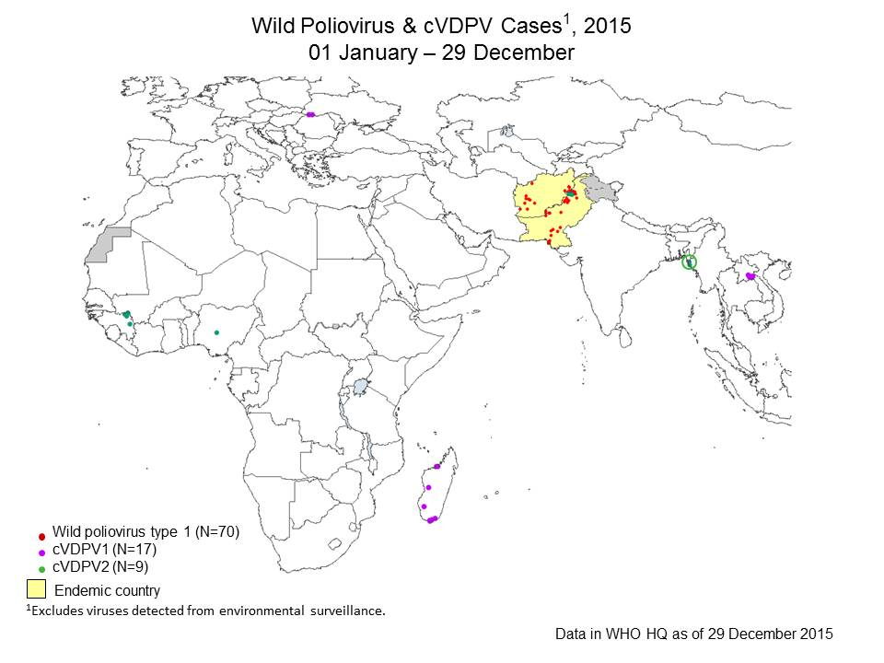

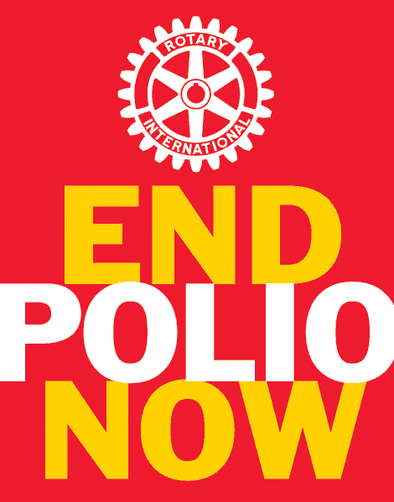
COMPILED BY
Dr.P.Narayana
Former Vice-Chairman,
Rotary’s India National Polio plus Committee

