WHY BIOMETRICS

Fingerprints never change


Finger prints are unique and non identical

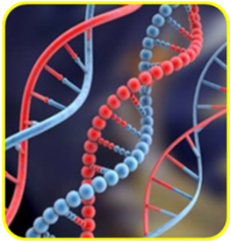
It’s our genetic code
Subject: - Introduction of Biometric Multiple Intelligence Analysis.

We as Success Coach continuously endeavor to find new innovative techniques to help parents know about their child’s innate talents, ways to nurture it and thus bringing contentment to their lives.

In this pursuit we came across a beautiful proverb -“EACH AND EVERY CHILD IS UNIQUE BLEND OF TALENTS, PERSONALITY TRAITS AND INGREDIENTS”………NO WHERE ELSE TO BE FOUND!!

PROGRAM EXPLANATION

This is a scientific set of evaluation systems built on the combined sciences of Brain Physiology, Embryology, Psychology and Dermatoglyphics. The process begins with the study of fingerprint, ridge patterns and generates a comprehensive report covering a host of different aspects affecting a person’s personal and professional life. It helps us discover our true nature as well as our potentialities, capabilities, strengths and weaknesses– the one we were born with and how can we incorporate this information into our personal and professional lives.

Since it has been proven that our finger-prints are uniquely intertwined with an individual's genetic composition and central nervous system, the Famous Fingers analysis can easily reveal our congenital qualities and talents.
The analysis tells us four important things
- Innate potentials of an individual.
- Our personality and characteristics.
- Learning sensitivity (ATD).
- Best career choices basis on our Multiple Intelligences.

The analysis is followed with a detailed counseling session explaining the report, suggesting future course and action plan which focus on key issues of career development, management and leadership styles and communication development.
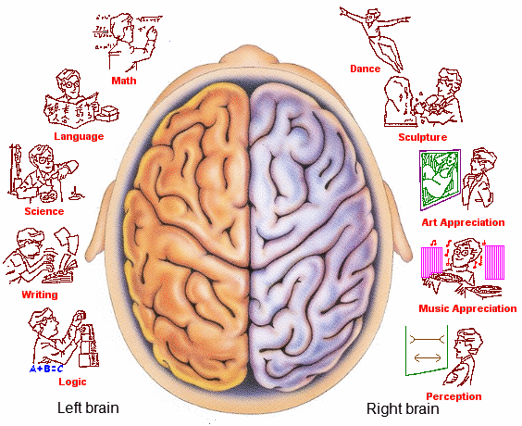
Roger Sperry won the Nobel Prize in 1981 for the split Brain theory

Since 1970, Soviet Union used Biometrics Test to select sportspeople.

Howard Gardner in 1981 concluded that Multiple Intelligence testing was better and more comprehensive than the IQ test.

The detailed test report would help a student/parents in the following:

- Discover and assess true nature, personality characteristics and special talents we are born with.
- Understand congenital strengths and areas of improvement – knowing this how parents can evolve right method of parenting to help their child flower forth as a genius.
- Best ways of learning and working.
- The sensitivity of left and right brain.
- Distribution of four quotients namely Emotional Quotient, Intelligence Quotient, Adversity Quotient and Creativity Quotient.
- Distribution of their Multiple Intelligences.
- Ascertain right choices in further education and career development.
- Understand their leadership and management styles – Pros and Cons.
- Discover and correct their Execution styles – Objective vs Conceptual.

The most adventurous journey to embark on; is the journey to yourself,
The most exciting thing to discover; is who you really are….

