
ROTARY FRIENDSHIP EXCHANGE

WELCOME TO District 5550


District 5550 is an all-Canadian district comprised of forty-seven Rotary Clubs with a total membership of about 1,730. There are 21 clubs in Saskatchewan, 23 in Manitoba, and 3 in northwest Ontario. The Clubs range in size from twelve to one hundred twenty members.

The District includes most of the Province of Saskatchewan, all of Manitoba and a portion of the northwest corner of Ontario. Although District 5550 is one of the largest Districts in the Rotary world, what makes it unique is its contribution to the development of Rotary. In 1910, with the establishment of the downtown Winnipeg Club, Rotary became international. Shortly after that the term Rotary International was adopted.
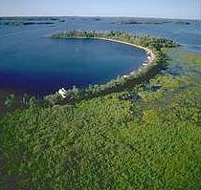
The three clubs in northwest Ontario, Sioux Falls, Dryden and Kenora are close to beautiful lake country called Lake of the Woods. The lucky Rotarians in this area are not far from great fishing and lots of options for all forms of canoeing, boating and sailing. Cruise picturesque Sunset Country aboard the MS Kenora on a guided tour past fabulous summer homes dotting the unspoiled wilderness. Fill your senses with the freshness of Sunset Country's clean piney air. Relish the solitude of beautiful boreal forests and witness unsuspecting moose foraging for dinner. Be awed by gorgeous granite landscapes, majestic waterfalls and glorious sunsets that bid goodnight to westernmost Ontario.
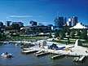

More than half of Manitoba’s population lives in the capital city of Winnipeg. This Provincial capital has elegant churches, beautiful parks and wind-swept avenues. Famed for its wealth of artistic attractions—including the world-renowned Royal Winnipeg Ballet—this prairie city enjoys a sizable reputation as the cultural capital of the Canadian West.

Recognized as a birder's paradise the Oak Hammock Marsh Interpretive Centre offers great viewing, as does Riding Mountain National Park, home to more than 260 bird species. A quick 10-minute drive south of Dauphin, Riding Mountain is located on the Manitoba Escarpment in south central Manitoba, near the geographical center of Canada. The park includes a diversity of landscapes: evergreen and hardwood forests, rolling hills, valleys, lakes and streams.

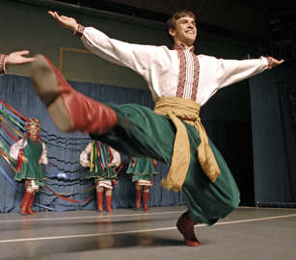
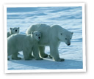
Like its sister provinces of Saskatchewan and Alberta, Manitoba is an ethnic mosaic of tradition and change. Manitobans are not one people but many. In Dauphin, Cossack riders parade through the streets to the sounds of balalaikas, and townsfolk in Ukrainian costume feast on pirogi, holupchi and other Slavic delicacies. The first large group of Mennonites to homestead in the Province came in 1874. Descendants of Icelanders who settled in Gimli celebrate their heritage with parades, songs and dances during the midsummer festival. The geography of Manitoba is dominated by Lake Winnipeg and the northern reaches of the Province are a tourist haven for sightings of the polar bear.



At harvestime, Saskatchewan’s wheat and canola fields shimmer like burnished gold flowing over a wide horizon punctuated only by the occasional silhouette of an elevator, once wooden, now more often concrete. It is said Saskatchewan is so flat a farmer can sit on his back porch and watch his dog run away for three days.

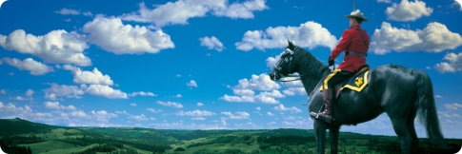

Although farming opened this part of the prairies, more than 50% of the Province is forest. But today, agriculture is no longer the dominant player in the economy. Mining has emerged as the prime contributor to the Province’s new found wealth. There are now about 30,000 active oil wells, and considerable supplies of natural gas are available. Saskatchewan is one of the world’s largest sources of potash and the underground mining of this fertilizer is flourishing. In the northern part of the Province, are several very rich uranium mines and diamond mining is actively pursued at the site of several formations of kimberlites.

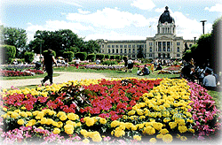
Regina, the capital of Saskatchewan is the home of the training centre for the Royal Canadian Mounted Police. A visit to their barracks and the newly completed RCMP Heritage Centre is a popular choice among tourists. Wascana Centre is known internationally as a beautifully landscaped park surrounding a 120-hectare lake located in the heart of the City of Regina. Within this 930-hectare parkland development may be found numerous important buildings including the Legislative Building. The park areas are attractively landscaped and are enjoyed by thousands of Regina citizens and tourists in both summer and winter.

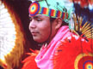
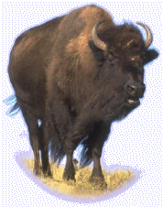
The Prairie Provinces are home to many of Canada’s First Nations People. An excellent display of their life style of several hundred years ago is celebrated in Saskatoon at the Wanuskewin Museum. This is the site of a buffalo jump, a location where tribes were able to hunt buffalo to gather provisions for the forthcoming winter. A number of First Nations People still follow the traditional ways in the northern parts of the Province. But many have moved to the cities and some have continued on to higher education. The First Nations University in Regina is a testament to the promise and future of their people.

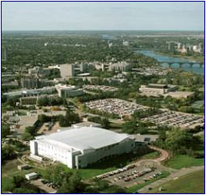
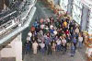
The city of Saskatoon is the home of the Province’s largest university. Adjacent to the Campus is a large complex known as Innovation Place. It houses over 120 firms engaged in research and development. Close by is the new research centre known as the Canadian Light Source. The Canadian Light Source is one of the largest scientific projects in Canada, and one of the most advanced synchrotrons in the world. This new research tool at the University of Saskatchewan will help to find Canadian solutions for global challenges in health, advanced materials and the environment. A synchrotron acts like a giant microscope. Intense beams of synchrotron light are generated to help scientists understand the nature and structure of molecules and materials. The Canadian Light Source is one of the most powerful in the world, producing synchrotron light that is millions of times brighter than sunlight.

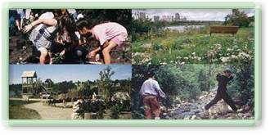
The Meewasin Valley Authority is an organization dedicated to protecting the natural and cultural heritage resources of the South Saskatchewan River Valley in Saskatoon. Wanuskewin Heritage Park hugs the west bank of the South Saskatchewan River, just three kilometres north of Saskatoon. Within its 760 acres there are 19 sites that represent the active society of Northern Plains Peoples.
A visit to District 5550 gives you an opportunity to learn many of the features of Canada’s prairie history, to understand the unique makeup of its people and to see how the prairie folk are moving ahead in the twenty-first century.
District 5550 Website: www.rotary5550.org

